ABSTRACT
In modern communication environments, individuals with hearing and speech impairments face significant challenges due to the lack of seamless, real-time translation of sign language into textual formats. Although recognition technologies have advanced, many existing systems lack the integration and temporal analysis required for practical application. Key issues include:
- Limited Real-Time Sign Recognition: Traditional models struggle with continuous movements.
- Insufficient Accuracy for Complex Gestures: Systems often fail to recognize fast gestures under varying conditions.
- Lack of Semantic Context: Most models perform simple label mapping without considering ASL grammar.
To address these, this project proposes a Real-Time Sign-to-Text Translation System using a multi-modal architecture. The system utilizes MediaPipe Holistic for 3D landmark extraction of hands, face, and pose, combined with a Long Short-Term Memory (LSTM) network for temporal sequence analysis. A Transformer-based NLP module then performs semantic correction, translating raw gestures into fluent English sentences to improve accessibility across education and healthcare.
INTRODUCTION OF TECHNIQUES
MODULE I – SPATIAL FEATURE EXTRACTION
The first stage of the proposed sign language recognition system focuses on spatial feature extraction from video frames. Sign language communication relies heavily on hand movements, facial expressions, and body posture. Therefore, capturing these visual cues accurately is essential before performing any gesture classification. This module employs modern computer vision techniques to extract skeletal landmarks representing the signer’s movements in a structured and computationally efficient manner.
1. Video Frame Acquisition : The system begins by capturing video frames from the input source using a real-time video capture mechanism. Each frame serves as an individual unit for further processing. Continuous frame acquisition enables the system to observe the spatial configuration of the signer over time and prepares the data for landmark detection.
2. MediaPipe Holistic Landmark Detection : To detect human body landmarks efficiently, the system utilizes the MediaPipe Holistic framework, which is designed for real-time perception pipelines. MediaPipe Holistic simultaneously detects landmarks for three major regions of the human body:
- Pose landmarks representing the upper body posture
- Hand landmarks capturing detailed finger articulations
- Face landmarks representing facial expressions and head orientation
The framework provides highly optimized models that can detect these landmarks from monocular RGB video frames with high accuracy and low computational overhead.
3. Skeletal Representation of Human Motion : Instead of processing raw image pixels, the system converts visual information into a skeletal representation composed of landmark coordinates. Each landmark corresponds to a specific point on the human body such as joints, fingertips, or facial keypoints. This representation captures the spatial structure of gestures while significantly reducing the dimensionality of the input data. As a result, the system becomes less sensitive to variations in lighting, background, and camera position.
4. Landmark Coordinate Normalization : The extracted landmarks are represented as normalized coordinate values relative to the frame dimensions. Normalization ensures that the spatial representation remains consistent regardless of the user’s distance from the camera or variations in image resolution. This step improves robustness and allows the system to generalize across different users and environments.
5. Feature Vector Construction : After detecting and normalizing the landmarks, the coordinates from pose, face, and hand regions are combined into a single structured feature vector. This feature vector represents the spatial configuration of the signer for a particular frame. By transforming raw visual data into a compact numerical representation, the module prepares the data for further temporal modeling and gesture recognition in the subsequent stages of the system.
LITERATURE SURVEY
SL NO. | Title of Paper | Journal Title with Year of Publication & Author | Technical Description | Research Gap
1 | MediaPipe-LSTM-Enhanced Framework for Real-Time Dynamic Sign Language Recognition in Inclusive Communication Systems | Engineering Reports, 2025, Wiley Online Library N Anithadevi, SK Palanisamy, S Saranya Rubini, S Shrestha | Uses MediaPipe Holistic to extract pose, face, and hand landmarks from video frames and convert them into skeletal feature vectors, which are processed using LSTM networks for dynamic sign recognition. | Focuses mainly on gesture classification using a specific dataset and deep sequential models; lacks emphasis on lightweight modular feature extraction for scalable real-time systems.
2 | Deep Learning-Based Sign Language Recognition Using Efficient Multi-Feature Attention Mechanism | IEEE Access 2025, Esma Yenisari and Sirma Yavuz | Proposes a deep learning framework using EfficientNet with a multi-feature attention mechanism to capture visual features such as hand shapes and facial expressions for sign recognition. | Concentrates mainly on isolated word recognition and does not support continuous sentence translation or real-time conversational sign language systems.
3 | Optimized Multi-Modal Conformer-Based Framework for Continuous Sign Language Recognition | IEEE Open Journal of the Computer Society, 2025, Neena Aloysius , Geetha M , And Prema Nedungadi | Introduces a multimodal Conformer-based framework combining RGB video features and heatmap embeddings with attention mechanisms for continuous sign language recognition. | Relies on computationally heavy video features and does not emphasize lightweight landmark-based approaches suitable for real-time deployment.

PROPOSED PROJECT - “Real-Time Sign-to-Text Translation System using Multi-Modal Feature Fusion and Semantic Correction (RSTTS-MMFFSC)”
The proposed system is designed to translate dynamic sign language gestures into meaningful textual output in real time using a multi-modal deep learning architecture. Unlike traditional gesture recognition systems that focus only on static hand shapes, this project captures comprehensive linguistic cues by integrating hand, face, and body pose landmarks.
The system operates through a structured processing pipeline. Live video input from a webcam is first processed using the MediaPipe Holistic framework to extract spatial landmarks representing hand joints, facial keypoints, and body posture. These landmarks are converted into normalized coordinate-based feature vectors, ensuring robustness against variations in lighting conditions, camera position, and background noise.
The extracted features are organized into temporal sequences and fed into a Long Short-Term Memory (LSTM) neural network. The LSTM model captures motion dynamics across consecutive frames and classifies the gesture into predefined sign word categories. The recognized word is displayed in real time along with a confidence score, forming the foundation of the translation process.
To enhance usability in conversational settings, subsequent modules incorporate temporal stabilization techniques such as majority voting and confidence thresholding. Additionally, a Transformer-based Natural Language Processing (NLP) module is integrated to convert raw sign gloss sequences into grammatically correct English sentences.
The entire pipeline is deployed within a Flask-based web application, providing a real-time interactive interface that displays the recognized word, confidence metrics, accumulated gloss sequence, and refined textual output. This integrated approach bridges the gap between computer vision-based gesture recognition and practical communication support systems for individuals with hearing and speech impairments.
HIGH LEVEL ARCHITECTURE DIAGRAM
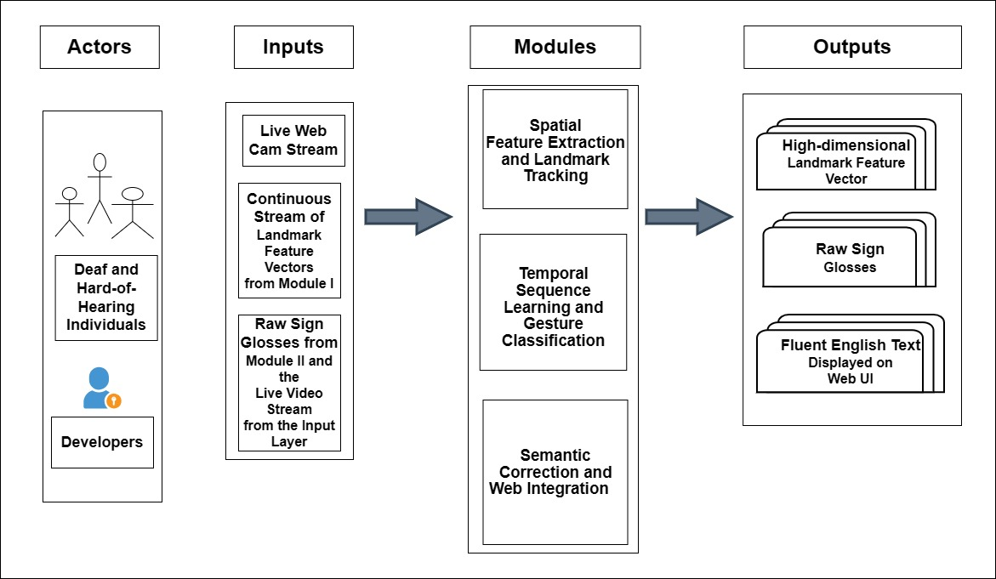
Fig 1.1: High-Level Architecture of the Proposed System
The high-level architecture of the proposed system consists of a multi-stage processing pipeline designed for real-time sign language recognition and translation. The system begins with live webcam input that captures continuous hand gestures, facial expressions, and body movements.
The captured frames are processed using the MediaPipe Holistic framework to extract spatial landmarks corresponding to hands, face, and body pose. These landmarks are normalized and structured into temporal sequences, which are then passed into an LSTM-based gesture classification module. The LSTM analyzes motion patterns across multiple frames to recognize dynamic sign words.
The predicted sign words are further processed through temporal stabilization mechanisms such as confidence thresholding and majority voting to ensure prediction consistency. The stabilized gloss sequence is then passed to a Transformer-based NLP module, which refines raw sign outputs into grammatically correct English sentences.
Finally, the entire workflow is integrated into a Flask-based web application that provides real-time interaction and display of recognition results.
PROJECT MODULES
Module - I : Spatial Feature Extraction and Landmark Tracking
This module serves as the primary input processing layer. It utilizes the MediaPipe Holistic framework to capture real-time video frames from the webcam. The module identifies and extracts high-fidelity 2D landmark coordinates with confidence scores for the hands, face, and body pose simultaneously. Instead of processing raw pixel data, which is computationally expensive and sensitive to background noise, this module converts the visual information into a normalized coordinate-based skeletal representation. This ensures robustness across varying lighting conditions, backgrounds, and camera distances while significantly reducing computational complexity.

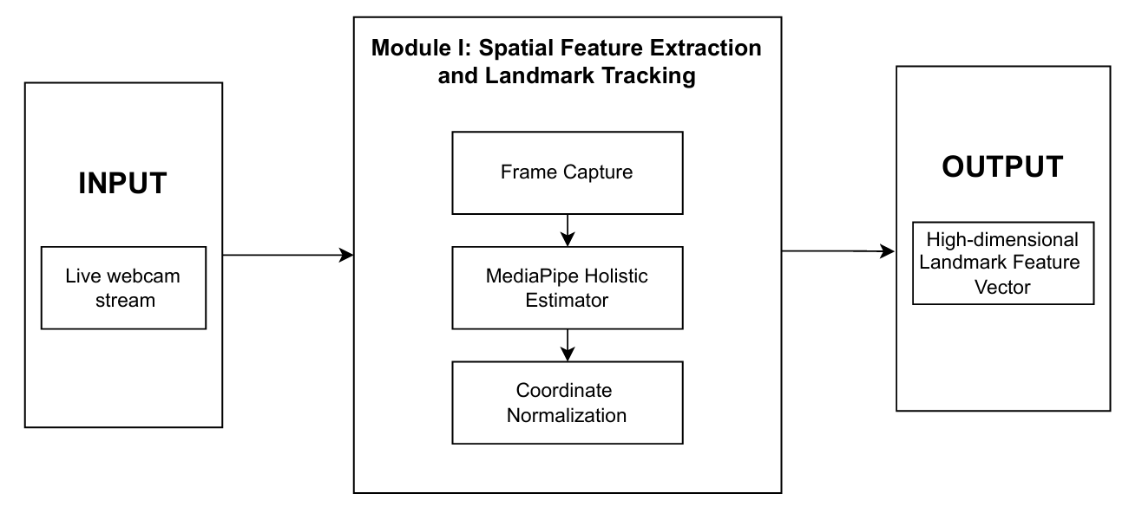
Fig 1.2: Spatial Feature Extraction and Landmark Tracking
Module - II : Temporal Sequence Learning and Gesture Classification
The second module focuses on interpreting movement over time. The normalized coordinate data generated by Module I is organized into sequential time-series buffers of fixed length. These sequences (T × 411 feature matrices) are processed using a Long Short-Term Memory (LSTM) neural network. Unlike standard image classifiers, the LSTM architecture retains information from previous frames, enabling the system to distinguish between gestures that share similar static hand shapes but differ in motion trajectories. This module effectively classifies dynamic gestures into raw sign labels or glosses.

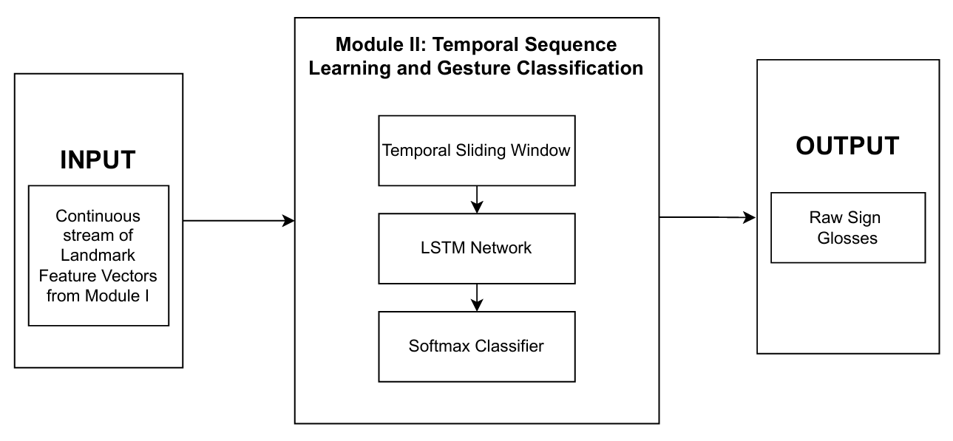
Fig 1.3: Temporal Sequence Learning and Gesture Classification
Module - III : Semantic Correction and Web Integration
The final module is responsible for linguistic refinement and user interaction. The raw recognized glosses generated by Module II are passed through a pre-trained Transformer-based Natural Language Processing model (T5-small). This model performs syntax reordering and grammatical correction, ensuring the final output adheres to standard English language structure rather than raw sign order. The complete pipeline is integrated into a Flask-based web application, providing a real-time interactive dashboard where the translated text is displayed clearly to the user.
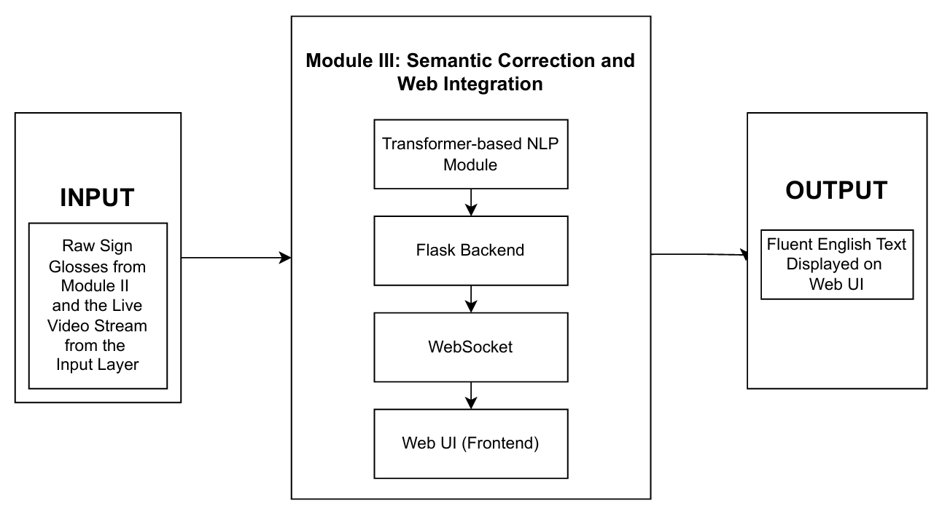
Fig 1.4: Semantic Correction and Web Integration
MODULE – I : BRIEF EXPLANATION
Module – I : Spatial Feature Extraction and Landmark Tracking
Module-I acts as the primary perception layer of the proposed system and is responsible for extracting meaningful skeletal features from live video input. The module captures real-time frames from the webcam through the Flask-based web interface.
Each captured frame is processed using the MediaPipe Holistic framework, which detects key landmarks corresponding to the human body pose, facial structure, and hand joints. These landmarks represent spatial coordinates of important points such as shoulders, elbows, wrists, fingertips, and facial keypoints.
Instead of processing raw pixel values, the system converts the detected landmarks into a normalized coordinate-based skeletal representation. This significantly reduces computational complexity while preserving essential spatial information required for sign language understanding.
The detected landmarks include:
- 33 pose landmarks
- 468 facial landmarks
- 21 landmarks for each hand
These landmarks are extracted for every frame and combined into a structured feature representation. The coordinates are normalized and converted into a fixed-dimension feature vector of size 411.
This feature vector represents the spatial configuration of the signer in a single frame and serves as the input to the next module for temporal gesture modeling.
The outputs of Module-I include:
- Pose landmarks
- Face landmarks
- Hand landmarks
- Normalized feature vector representation
These outputs are visualized in real time on the web interface and form the foundation for gesture recognition in the subsequent modules.

DECOMPOSITION DIAGRAM
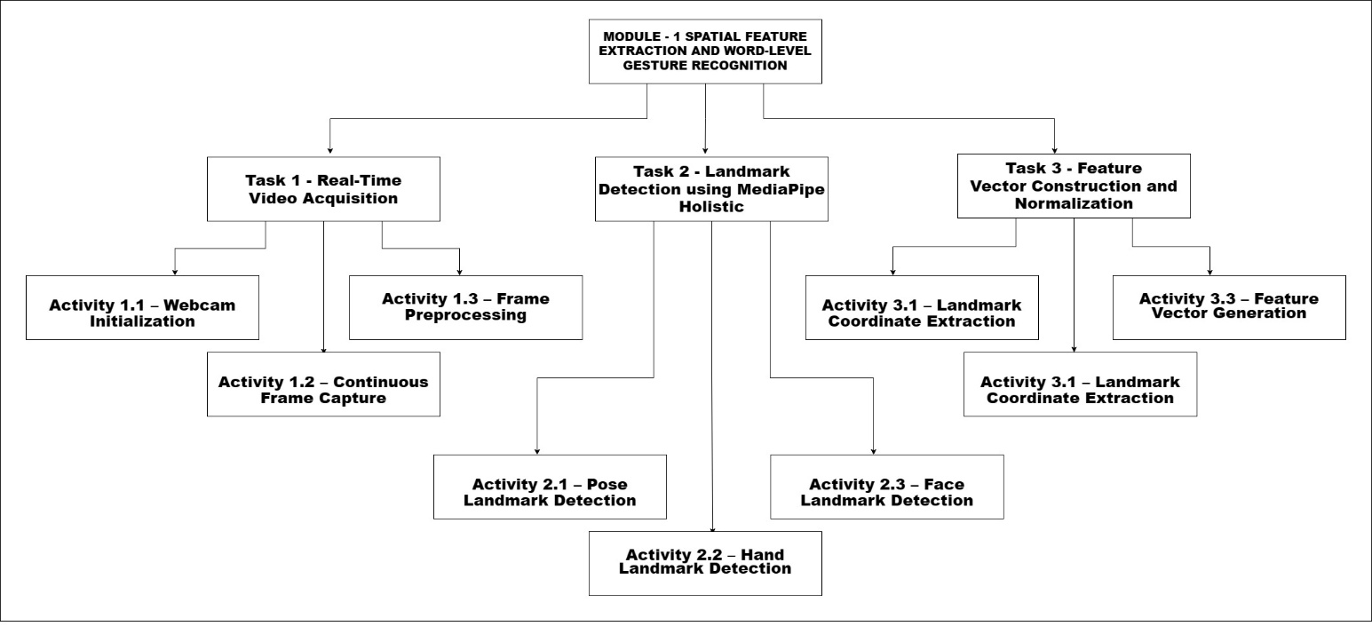
Fig 1.5: Module – 1 Decomposition Diagram
DETAIL DIAGRAM WITH INPUT AND OUTPUT FOR MODULE – I
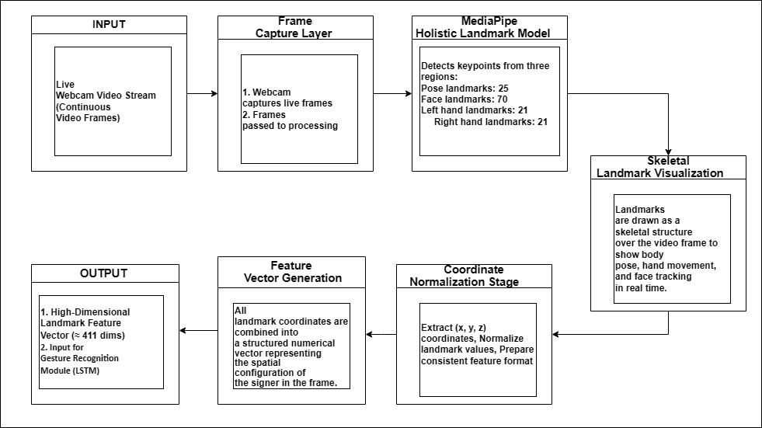
Fig 1.6: Detail Diagram with Input and Output for Module – I
DEMO FOR MODULE – I
The demonstration of Module–I focuses on the spatial feature extraction stage of the proposed sign language recognition system. This module illustrates how visual information from video frames is converted into skeletal landmark representations using computer vision techniques.
During the demonstration, the system is launched through the Flask-based web interface. The webcam captures live video frames and displays them on the interface. Each frame is processed in real time using the MediaPipe Holistic framework to detect human body landmarks.
The following steps are demonstrated:
1. Real-Time Frame Capture : The webcam captures continuous video input and displays the live feed on the user interface.
2. Landmark Detection using MediaPipe : For each frame, the MediaPipe Holistic model detects key landmarks corresponding to three major regions:
- Body pose landmarks
- Face landmarks
- Hand landmarks
These landmarks represent important spatial points such as joints, fingertips, and facial keypoints.
3. Skeletal Landmark Visualization : The detected landmarks are visualized as a skeletal structure overlaid on the video frame. This allows the user to observe how the system tracks body posture, hand movement, and facial expressions in real time.
4. Landmark Count and Feature Monitoring : The system displays technical details such as:
- Number of pose landmarks detected
- Number of face landmarks detected
- Number of hand landmarks detected
- Total number of landmarks detected per frame
These values confirm that the landmark extraction process is functioning correctly.
5. Feature Vector Generation : The extracted landmark coordinates are converted into a fixed-dimensional numerical feature vector representing the spatial configuration of the signer in each frame. This feature vector will be used as input for gesture recognition in the next stage of the system. The demonstration highlights the capability of the system to accurately extract skeletal features from live video input. This validates the effectiveness of Module–I in transforming raw visual data into structured spatial representations that can be utilized for sign language recognition in later modules.

SCREENSHOTS
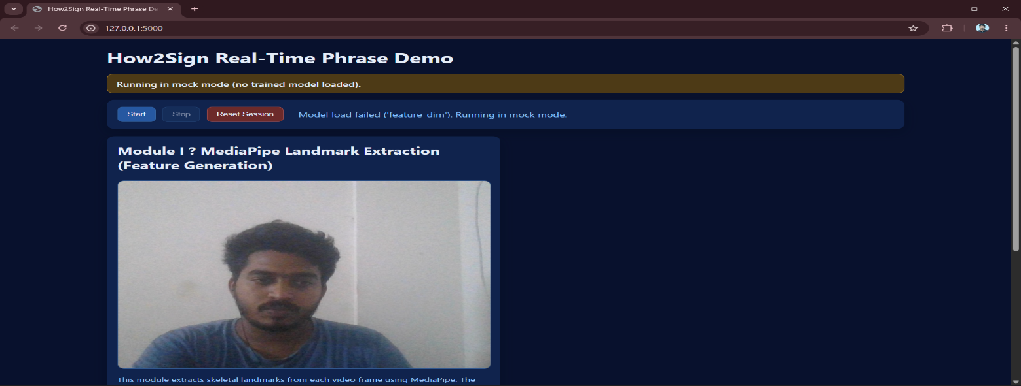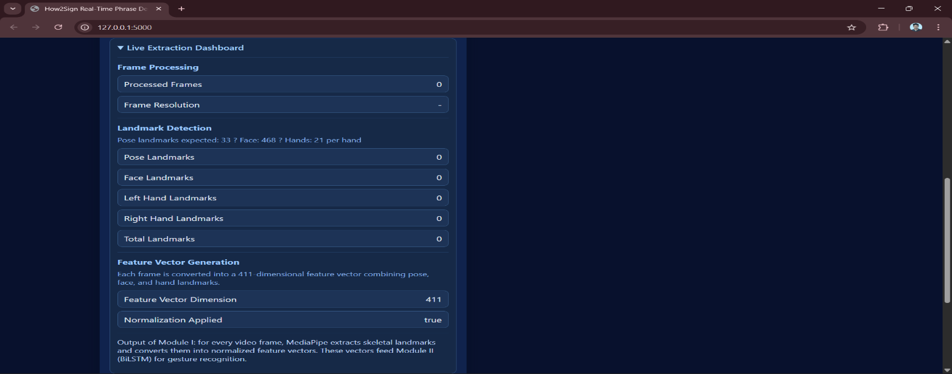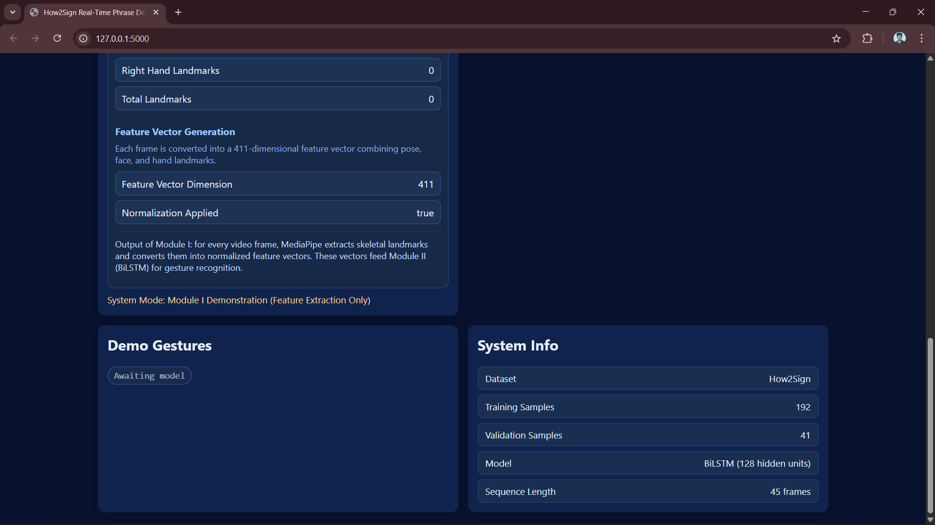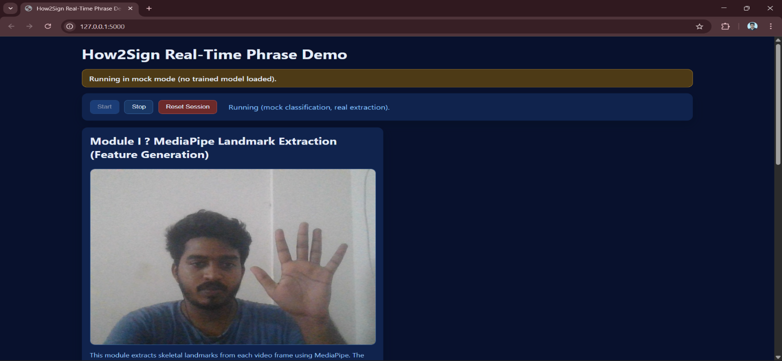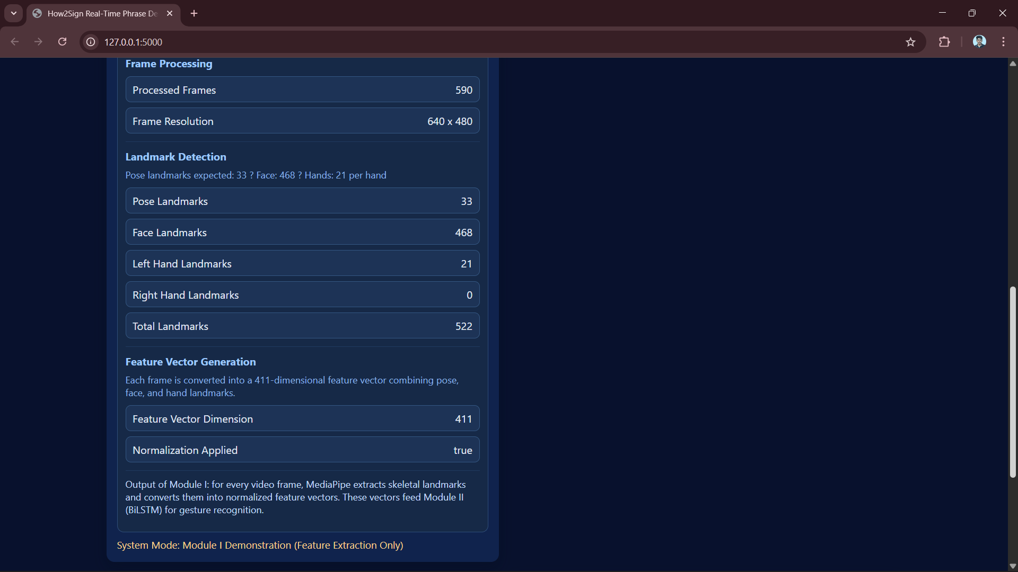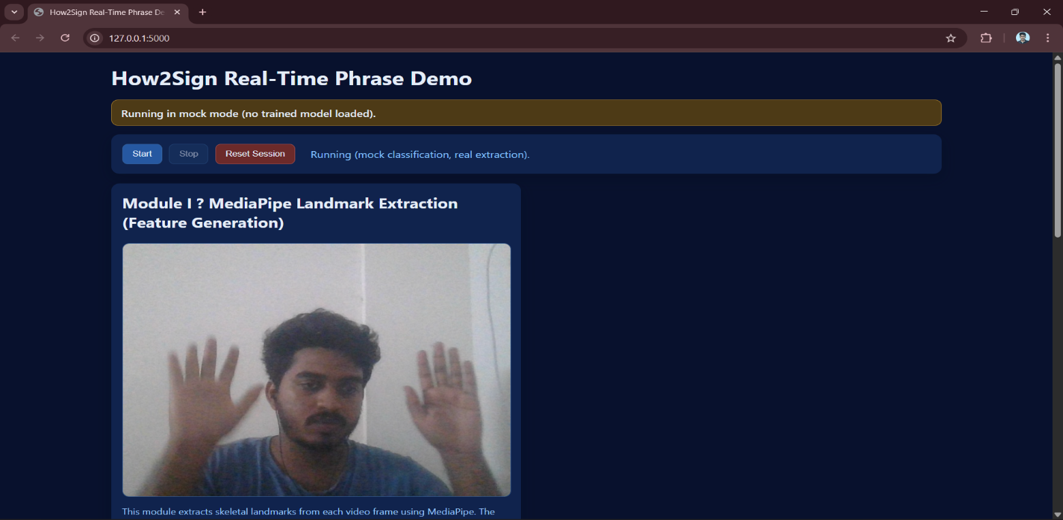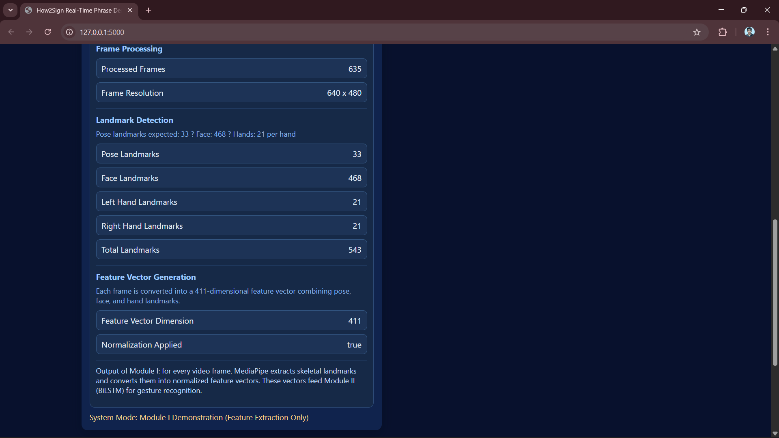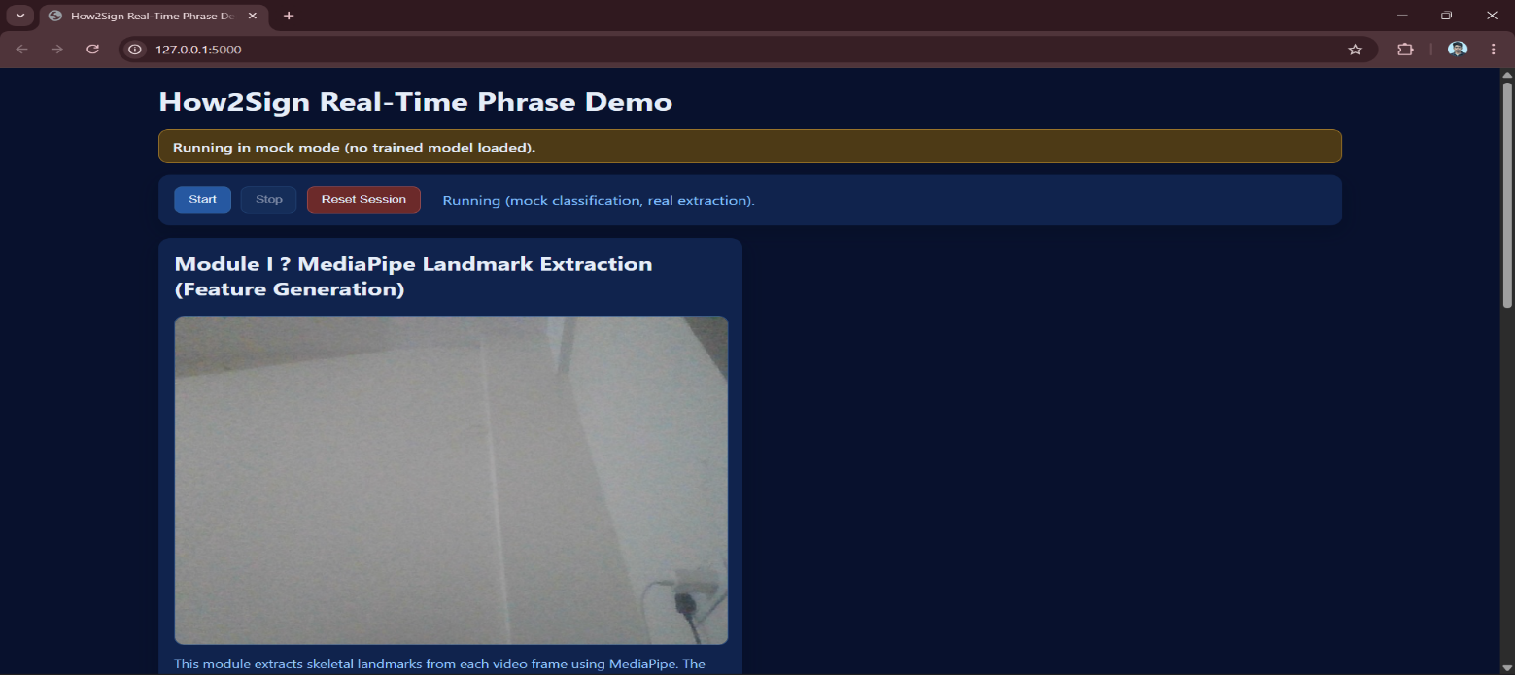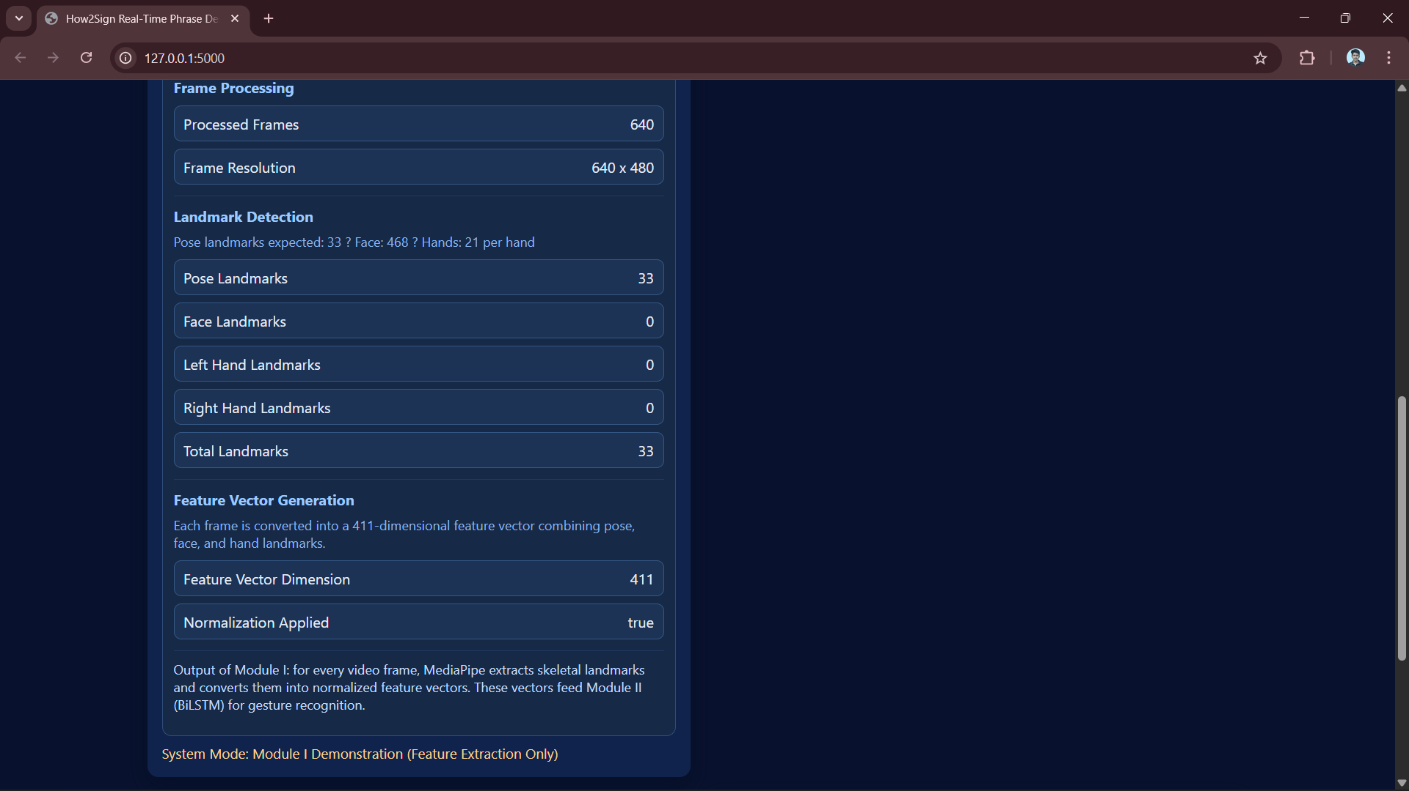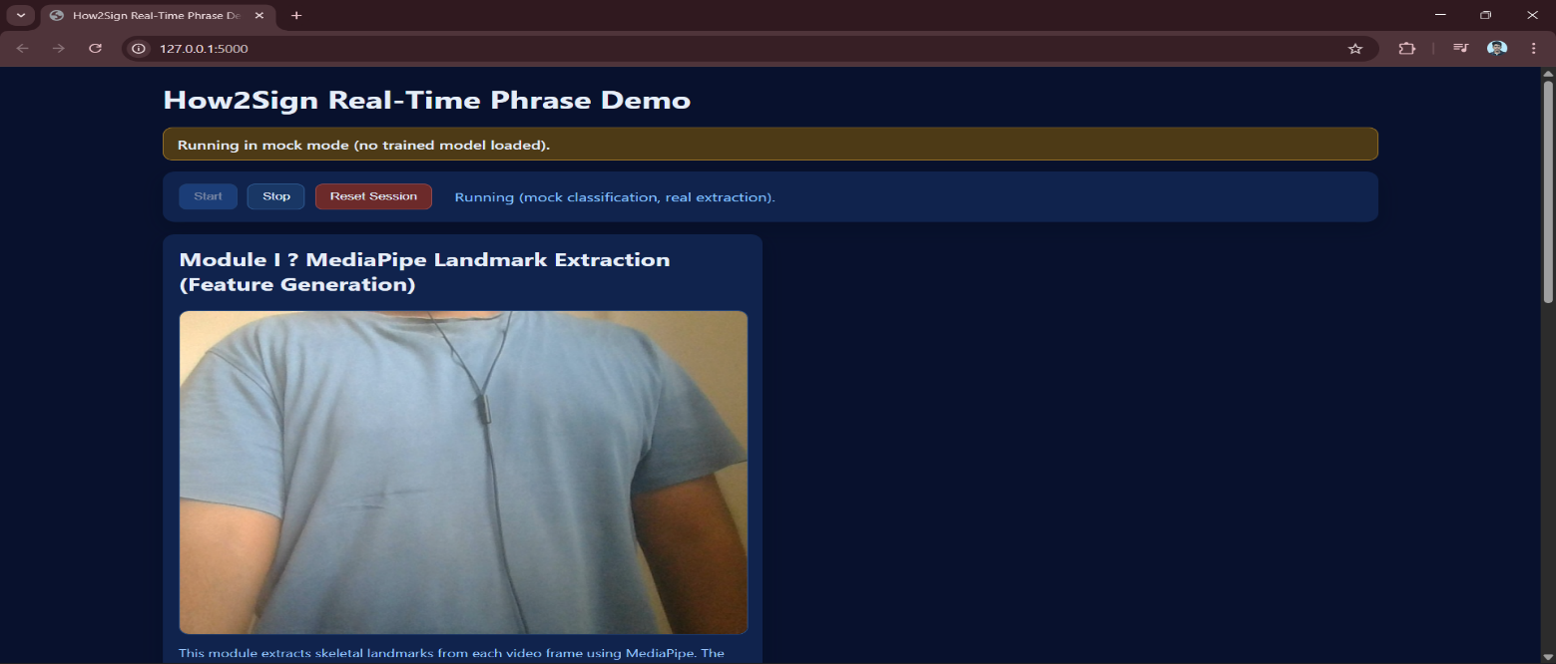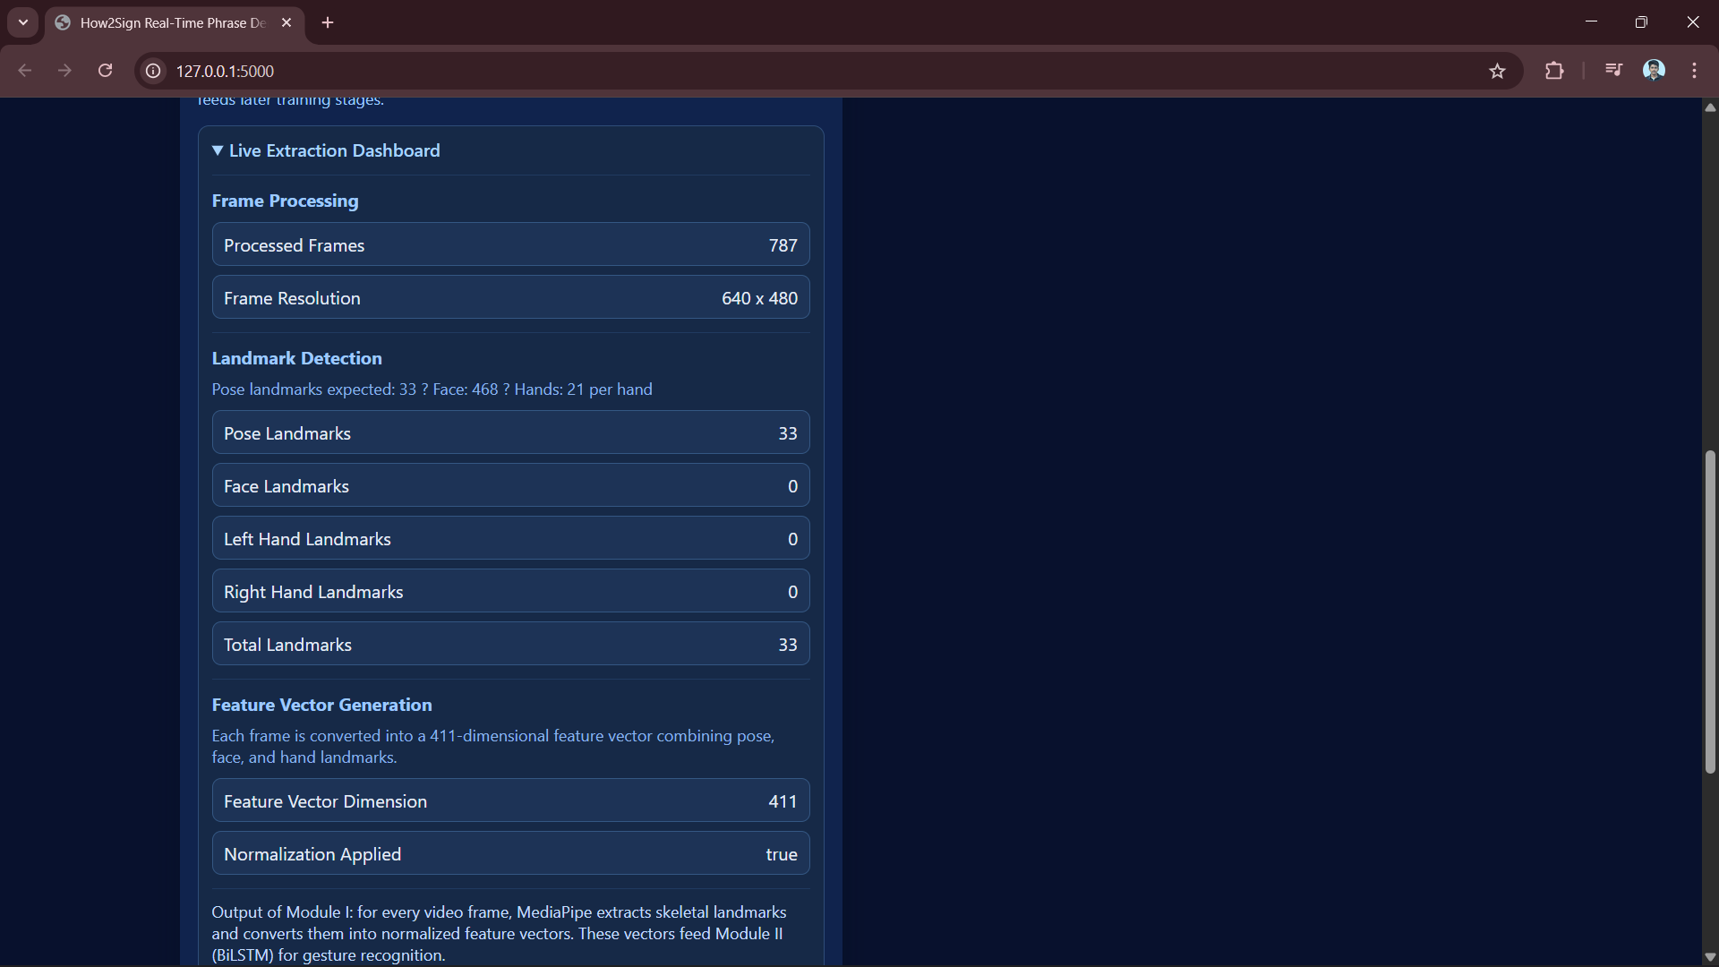

REFERENCES
[1] A. Duarte, S. Palaskar, L. Ventura, D. Ghadiyaram, K. DeHaan, F. Metze, J. Torres, and X. Giro-i-Nieto, “How2Sign: A Large-scale Multimodal Dataset for Continuous American Sign Language,” arXiv preprint arXiv:2008.08143, 2021.
[2] A. Rastgoo, K. Kiani, and S. Escalera, “Hand Sign Language Recognition Using Multi-View Hand Skeleton,” IEEE Transactions on Multimedia, vol. 22, no. 9, pp. 2335–2347, 2020.
[3] A. Shegokar, T. Kale, L. Patil, and P. Gupta, “Sign Language Detection System Using CNN and HOG: Bridging the Communication Gap for Deaf and Hearing Communities,” in Proceedings of the 2025 IEEE International Conference on Interdisciplinary Approaches in Technology and Management for Social Innovation (IATMSI), 2025, pp. 1–6.
[4] Camillo Lugaresi, J. Tang, H. Nash, C. McClanahan, E. Uboweja, M. Hays, F. Zhang, C. Chang, M. G. Yong, J. Lee, W. Chang, W. Hua, M. Georg, and M. Grundmann, “MediaPipe: A Framework for Building Perception Pipelines,” arXiv preprint arXiv:1906.08172, 2019.
[5] H. Cooper, B. Holt, and R. Bowden, “Sign Language Recognition,” in Visual Analysis of Humans, Springer, London, 2011, pp. 539–562.
[6] K. Roh, H. Lee, E. J. Hwang, S. Cho, and J. C. Park, “Preprocessing MediaPipe Keypoints with Keypoint Reconstruction and Anchors for Isolated Sign Language Recognition,” in Proceedings of the 11th Workshop on the Representation and Processing of Sign Languages (LREC-COLING), 2024, pp. 323–334.
[7] Lionel Pigou, A. van den Oord, S. Dieleman, M. Van Herreweghe, and J. Dambre, “Beyond Temporal Pooling: Recurrence and Temporal Convolutions for Gesture Recognition in Video,” arXiv preprint arXiv:1506.01911, 2016.
[8] Muhammad Tasnimsyamim Abdul Raki, A. Izhar, N. Japar, and M. C. Y. Kai, “Transformer-Based Isolated Sign Language Recognition Pipeline with Mediapipe Hand-Pose Keypoints,” Preprint Research Paper, 2025.
[9] N. C. Camgoz, O. Koller, S. Hadfield, and R. Bowden, “Sign Language Transformers: Joint End-to-End Sign Language Recognition and Translation,” in Proceedings of the IEEE/CVF Conference on Computer Vision and Pattern Recognition (CVPR), 2020, pp. 10020–10030.
[10] Neena Aloysius, Geetha M., and P. Nedungadi, “Optimized Multi-Modal Conformer-Based Framework for Continuous Sign Language Recognition,” IEEE Open Journal of the Computer Society, Vol. 6, pp. 739–749, 2025.
[11] S. Alyami, H. Luqman, and M. Hammoudeh, “Isolated Arabic Sign Language Recognition Using a Transformer-Based Model and Landmark Keypoints,” ACM Transactions on Asian and Low-Resource Language Information Processing, vol. 23, no. 1, 2024.
[12] S. Mitra and T. Acharya, “Gesture Recognition: A Survey,” IEEE Transactions on Systems, Man, and Cybernetics, Part C: Applications and Reviews, vol. 37, no. 3, pp. 311–324, May 2007.
[13] T. Starner and A. Pentland, “Real-Time American Sign Language Recognition from Video Using Hidden Markov Models,” in Proceedings of the International Symposium on Computer Vision 2002, pp. 265–270.
[14] T. Tao, Y. Zhao, T. Liu, and J. Zhu, “Sign Language Recognition: A Comprehensive Review of Traditional and Deep Learning Approaches, Datasets, and Challenges,” IEEE Access, vol. 12, pp. 75034–75060, 2024.
[15] Z. Cao, G. Hidalgo, T. Simon, S. E. Wei, and Y. Sheikh, “OpenPose: Realtime Multi-Person 2D Pose Estimation Using Part Affinity Fields,” IEEE Transactions on Pattern Analysis and Machine Intelligence, vol. 43, no. 1, pp. 172–186, 2021.

